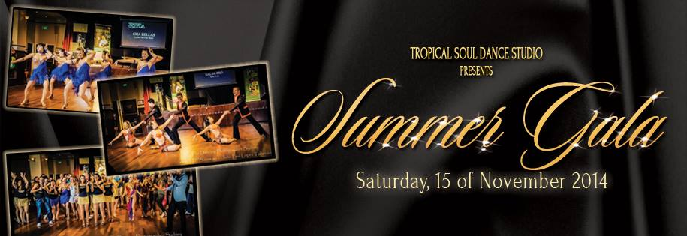

PROGRAM OF THE NIGHT

7:00pm - Doors Open
7:15pm – Intro to Latin Dance class
8:15pm – TROPICAL SHOW SET 1
9:15pm - Party time
11.00pm – SHOW SET 2
11.20pm – More partying and dancing!
1:00am - Party finishes

SHOW ORDER
TROPICAL SHOW SET 1
Ragga Riddimz – Dancehall
Steven & Alexis – Bachata
Project Salsa – Salsa
Cubachata – Bachata
B-Unit – Bachata
Salsa Ladies – Salsa
Cuban Soul – Cuban Salsa
Ladies Stylz – R&B
Conversa de Samba – Brazilian Samba
Zoukers – Zouk-Lambada
Swing Skool – West Coast Swing
Salsa Elite – Salsa
Josie & Steve – Salsa
GALA SHOW SET 2
Armand & Liz – Kizomba
Bachateros Advanced - Bachata
Peter & Michelle – West Coast Swing
Salsa Pro Team – Salsa
We hope you enjoy this amazing night!
www.tsdance.com.au

